Name: _______________________ Class: __________ Date: _______
Instructions: Write answers in the right-hand column. Score: ___________ / 42 marks

Section A—Multiple choice (10 marks)

 | How many structural isomers will have the formula C₄C₉Cl?  A 2  B 3  C 4  D 5 | C | 1
 | A compound has the formula C₇H₁₄. Which one of the following could it be?  A A straight chain alkane  B An alkene with one double bond  C A cycloalkene  D An aromatic hydrocarbon (a hydrocarbon containing a benzene ring) | B | 1
 | When an organic compound was treated with chlorine, Cl₂, in the presence of ultraviolet light, the major reaction product was chlorocyclohexane. Which one of the following was the original organic compound?  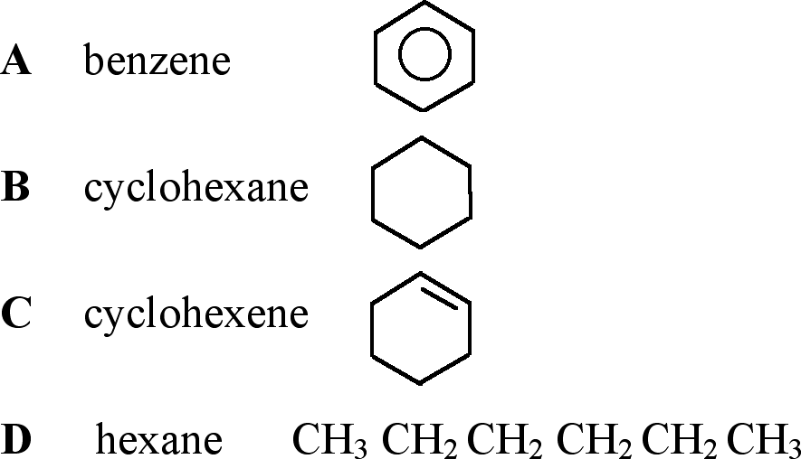 | B | 1
 | A particular organic compound has the formula of  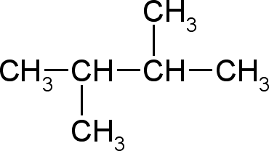  Which of the following statements about this compound is true?  A The name of the compound is 2,3–dimethylhexane.  B When mixed with a solution of bromine the orange colour of the bromine will rapidly fade.  C It will burn in an excess of air to form carbon dioxide and water.  D It will form geometric isomers. | C | 1
 | Each organic compound has at least one correct name. How many of the following names could NOT be correct?  - 1,2–dimethylpropane  - but–3–ene  - 2–methylbut–2–ene  - 1,1,1–trimethylcyclopentane  - trans–hex–2–ene  A 1  B 2  C 3  D 4 | C | 1
 | Which formula represents two substances that are geometric (cis/trans) isomers?  A C₄H₁₀  B C₃H₆  C CH₂=CHCH₂CH₃  D CH₃CH=CHCH₂CH₃ | D | 1
 | Which of the following pairs of compounds are pairs of isomers?  i heptane and 2–methylheptane  ii pentane and cyclopentane  iii hex–2–ene and cyclohexane  iv 2–methylhexane and ethylpentane  A iii and iv  B i and ii  C ii and iii  D i and iv | A | 1
 | If an equal amount, in mole, of each of the following is burned in excess oxygen, which will give the greatest mass of CO₂?  A C₂H₄  B C₂H₆  C C₃H₈  D C₄H₈ | D | 1
 | Which of the following statements best explains the stability of the benzene ring?  A Benzene is an unsaturated hydrocarbon.  B The benzene ring structure contains three double bonds.  C Six delocalised electrons are present in the ring structure of benzene.  D Cyclic hydrocarbons are more stable than straight chain hydrocarbons. | C | 1
 | Which of the following reactions are substitution reactions?  i CH₄ + Cl₂ → CH₃Cl + HCl  ii CH₂=CH₂ + Br₂ → CH₂Br–CH₂Br  iii CH₂=CH₂ + H₂ → CH₃–CH₃  iv C₆H₆ + Cl₂ → C₆H₅Cl + HCl  A i and iv  B ii and iii  C i, iii and iv  D ii, iii and iv | A | 1

Section B—Written answers (32 marks)

 | Give the IUPAC systematic name for each of the following compounds:  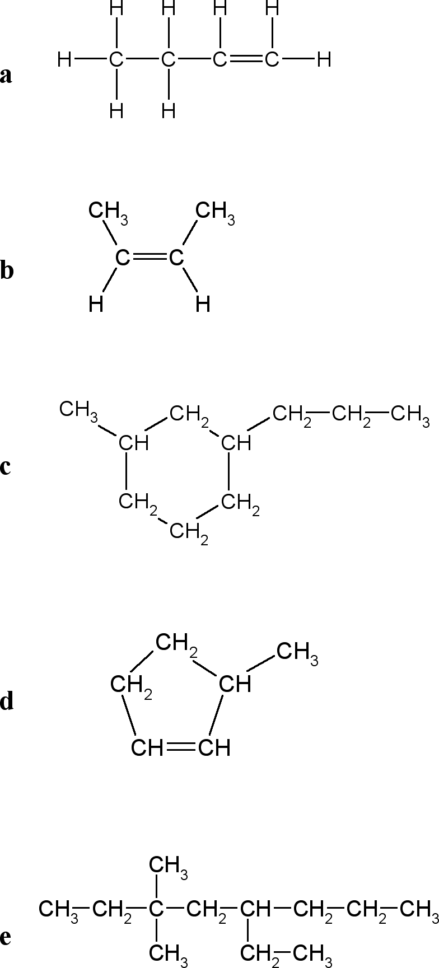 | a but-1-ene  b cis-but-2-ene  c 1-methyl-3-propylcyclohexane  d 3-methylcyclopentene  e 5-ethyl-3,3-dimethyloctane | 5
 | Give the structural formulas and names of the non–cyclic structural and geometrical isomers with the molecular formula of C₅H₁₀. | 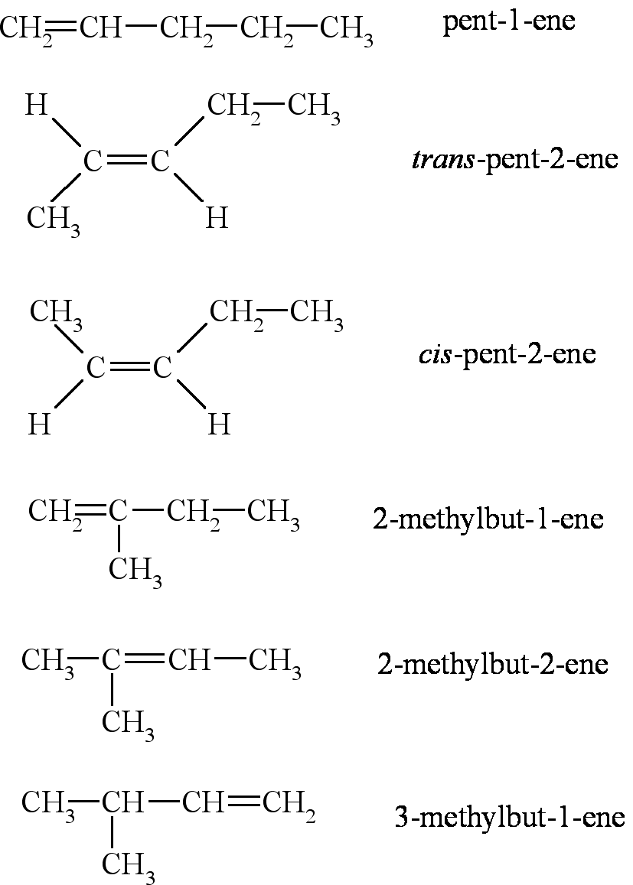 | 6
 | Give the structural formulas of the following compounds:  a 3–methyloctane  b 2,2–dimethylhex–3–ene  c ethylcyclopentane  d 1,2–dibromobenzene  e 3–ethyl–4–methylcyclohexene  f cis–1,2–dichloropropene | 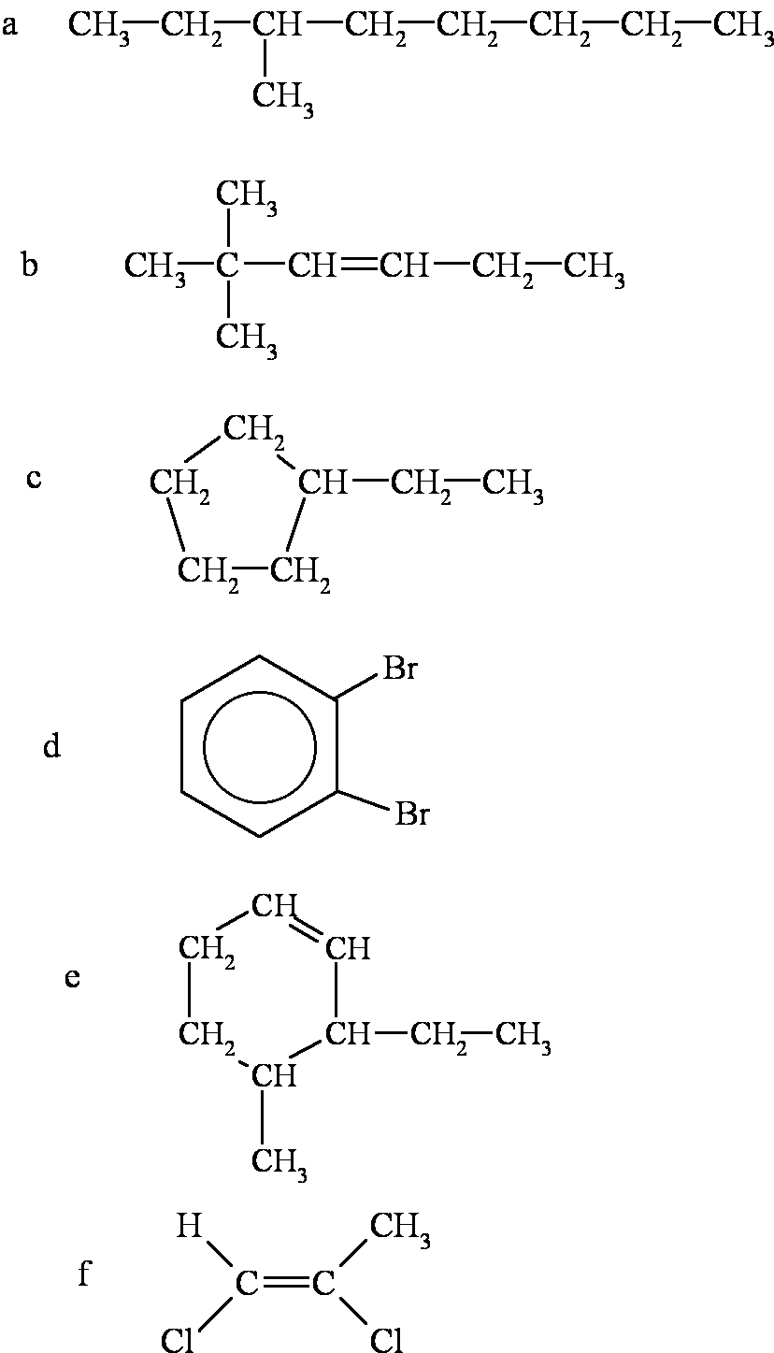 | 6
 | Write balanced equations for the following reactions. Use structural formula for the organic compounds:  a Propene and chlorine gases are mixed and allowed to react, in the absence of ultraviolet light.  b Dimethylpropane is mixed with bromine in a 1:1 mole ratio and placed in sunlight for several hours.  c Cyclopentene is reacted with hydrogen, in the presence of a catalyst.  d Hexane is burnt in the presence of an excess of air.  e Benzene reacts with bromine in the presence of a catalyst. | 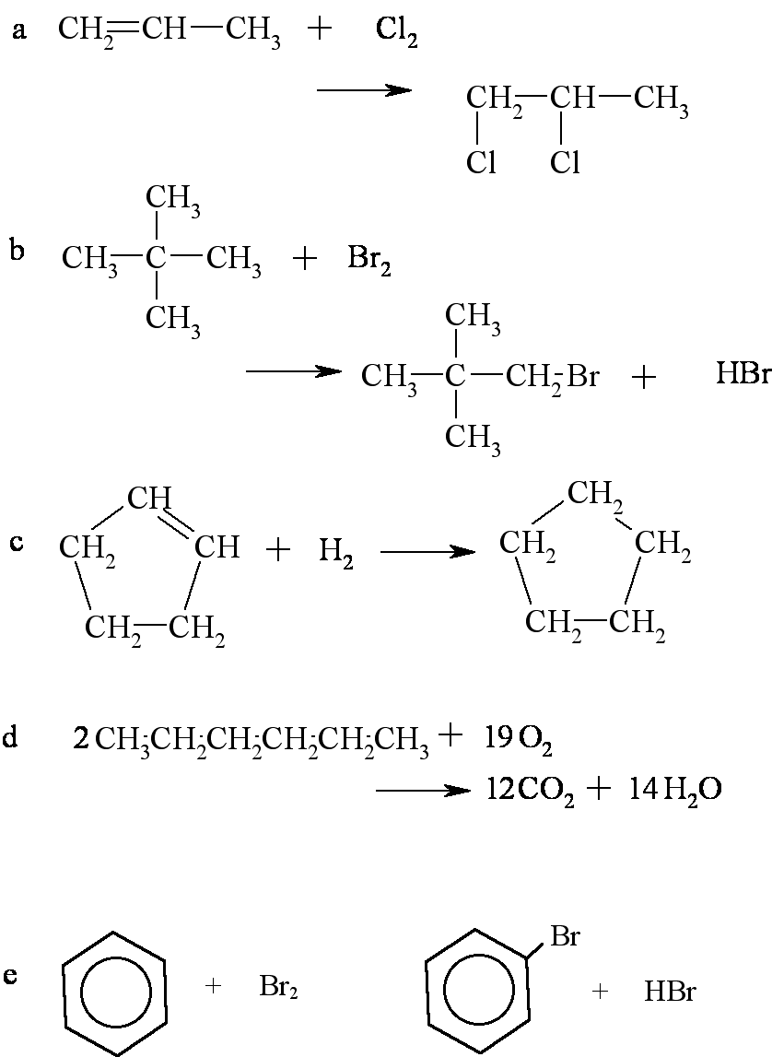 | 10
 | Identify by structural formula an example of each of the following:  a a branched chain alkane containing five carbon atoms per molecule  b an alkene other than pent-1-ene containing five carbon atoms per molecule  c an aromatic compound containing eight carbon atoms per molecule  d a cyclic compound that would rapidly decolourise a bromine solution  e a compound containing eight hydrogen atoms per molecule that would undergo an addition reaction with chlorine. | There are other possible answers apart from the ones given below.  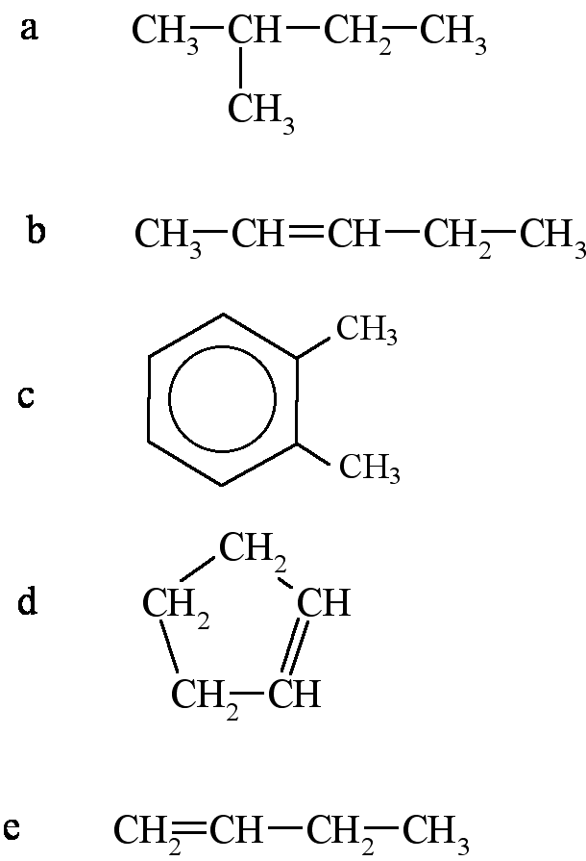 | 5

